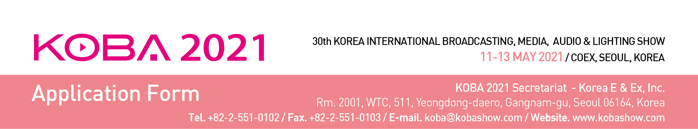
1. Applicant Manufacturer □ Importer □
Company Name
Company  Details | Address
 | Country |  |  | Tel
 | URL |  |  | Fax
Contact | Name |  |  | E-mail
 | Dept. |  |  | Position
Main Exhibits
□ Please contact our Korean agent / representative for further communication.
Agent Name |  |  |  | Tel.
Contact Person |  |  |  | E-mail

2. Type of Booth Space (1 booth: 3 x 3 = 9 sqm)
□ Space Only | USD 3,400 X ________ Booth(s) = USD __________________
□ Shell Scheme | USD 4,200 X ________ Booth(s) = USD __________________

* Special Benefit: Exhibitors of KOBA 2019 will be given a USD 100 discount per 9sqm of space only charge.
* Early Bird Discount: A USD 100 discount per 9sqm is applied to exhibitors who pay the full amount of booth charge
by Jan. 15th, 2021. (More than one discount may be applied.)
* Shell Scheme package includes: Fascia board with company name & logo, partition wall paneling, lighting, pytex,
an information desk with a chair, one round table with 4 chairs, and a wastebasket.
3. Booths Configuration
□ Single-row Booths □ Double-row Booths (for more than four)
□ Other type Booths (please contact Secretariat Office)
4. Payment Options
□ Cheques / Bank drafts should be made to: Korea E & Ex Inc.
□ Telegraphic transfer can be made to: Bank: Woori Bank
Branch: Korea World Trade Center
Account No.: 1081-500-336520
SWIFT Code: HVBKKRSE
Account Holder: Korea E & Ex Inc.
Bank Address: 511, Yeongdong-daero, Seoul, Korea

We hereby apply for exhibit space at the KOBA 2021. We agree to abide by the Rules and Regulations of Participation stated on the reserve side of this application form.

Authorized Person _____________________ Title ________________________

Signature _____________________ Date _______________________

