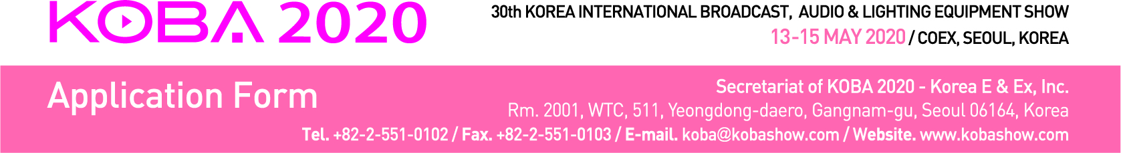
1. Applicant Manufacturer □ Importer □
Company Name
Company  Details | Address
 | Country |  |  | Tel
 | URL |  |  | Fax
Contact | Name |  |  | E-mail
 | Dept. |  |  | Position
Main Exhibits
□ Please contact our Korean agent / representative for further communication.
Agent Name |  |  |  | Tel.
Contact Person |  |  |  | E-mail

2. Type of Booth Space (1 booth: 3 x 3 = 9 sqm)
□ Space Only | USD 3,400 X ________ Booth(s) = USD __________________
□ Shell Scheme | USD 4,200 X ________ Booth(s) = USD __________________

* Special Benefit: Participants of KOBA 2019 will be given USD 100 discount from the booth charge.
* Early Bird Discount: Exhibitors who pay the full amount of booth charge by Jan. 15th, 2020
will be given USD 200 discount from the booth charge. (Both benefits can be applied duplicable.)
* Shell Scheme package includes: Fascia board with company name & logo, partition wall paneling, lighting, carpet,
information desk with a chair, one round table with 4 chairs, and a wastebasket.
3. Booths Configuration
□ Single-row Booths □ Double-row Booths (for more than four)
□ Other type Booths (please contact Secretariat Office)
4. Payment Options
□ Cheques / Bank drafts should be made to: Korea E & Ex Inc.
□ Telegraphic transfer can be made to: Bank: Woori Bank
Branch: Korea World Trade Center
Account No.: 1081-500-336520
SWIFT Code: HVBKKRSE
Account Holder: Korea E & Ex Inc.
Bank Address: 511, Yeongdong-daero, Seoul, Korea

We hereby apply exhibit space for the KOBA 2020. We agree to abide the Conditions and Regulation of Participation states on reverse side of this application form as defined in the Exhibitor's Service Manual.

Authorized Person _____________________ Title ________________________

Signature _____________________ Date _______________________

